Activity 2- Calculating Seconds

Matthew Foley

Programming in C#CST-150

Mark Smithers

2/23/25

<https://www.loom.com/share/42091828adcd4d3f9045b0b7ab8230e7?sid=8f9d6d28-5880-4a6a-b183-2476cc92af09>

The main page for display is still under some contemplations such as weather to continue to include pictures or not and how to properly format the information while being able to add more. As of now, this is a decent prototype. A screenshot of a computer program
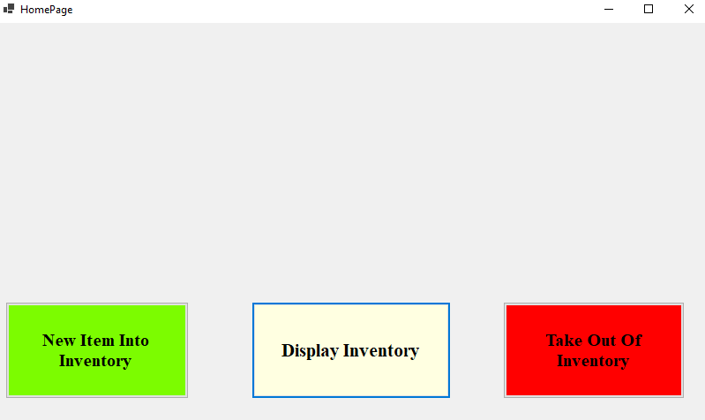

The current prototype for the home page. There will be a search bar and some more advanced searches above the current 3 buttons, but for now this is a good place to lay a foundation

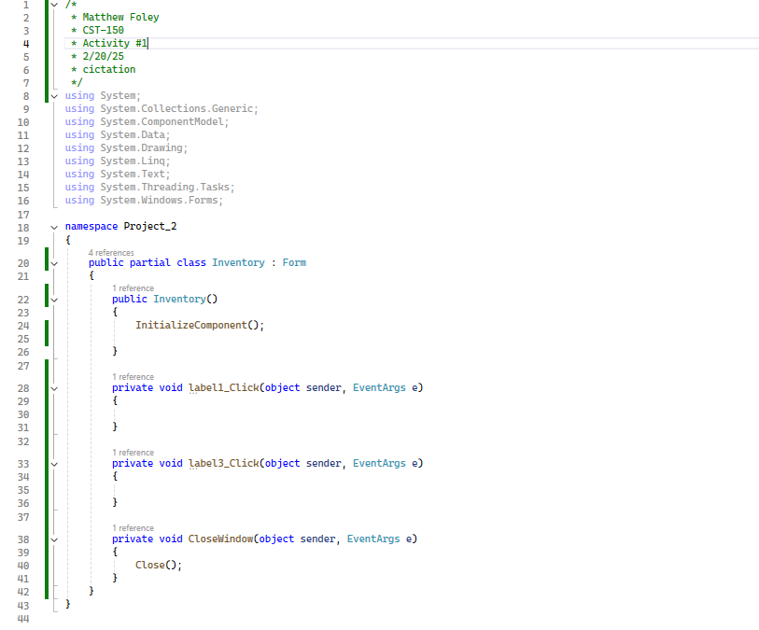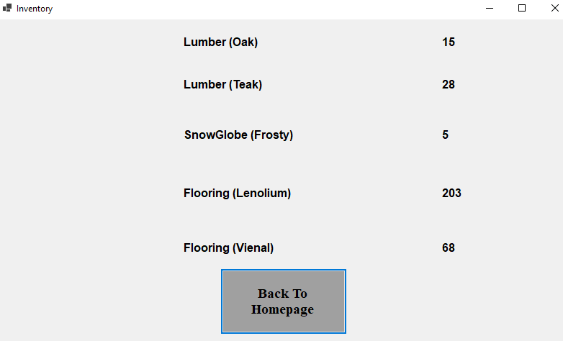

Still a work in progress for an inventory but, it is at least a good starting place, with plenty of workroom. The only foreseeable problem is to get the pages to play nicely with each other, but that should slowly start to solve itself as the weeks progress.

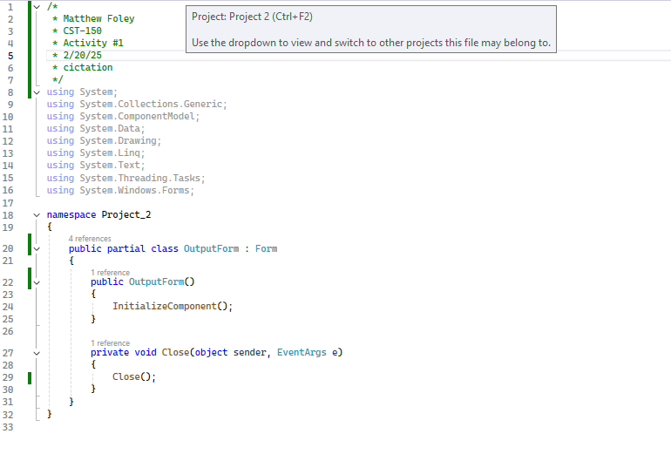

No picture for these yet since they are still work in progress forms for the input and output forms.

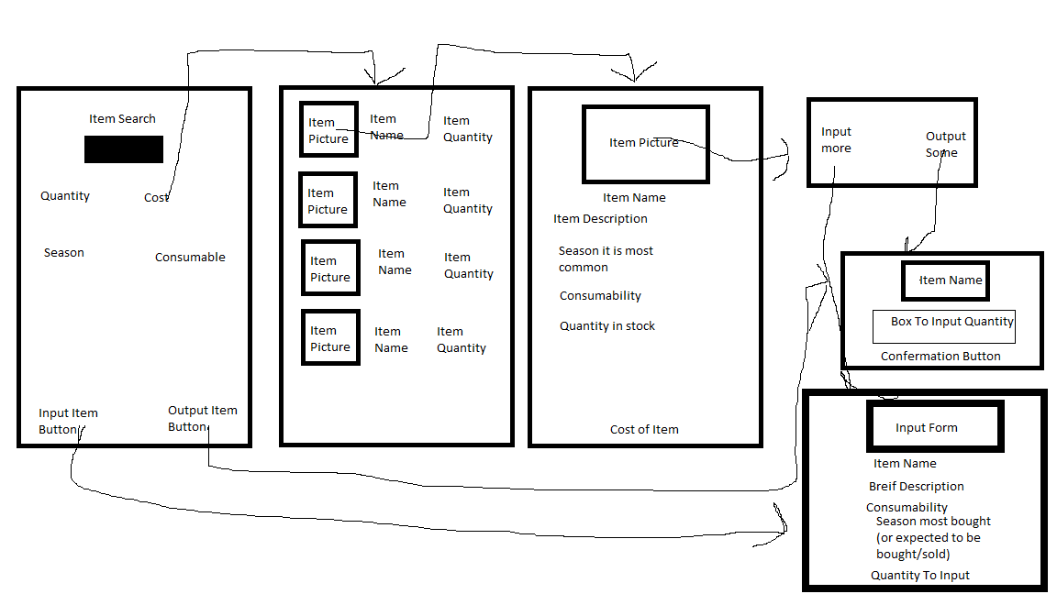

The current wireframe remains unchanged from the original, if any you could argue the middle display button as a change, but the overall flow of the form should be unchanged.

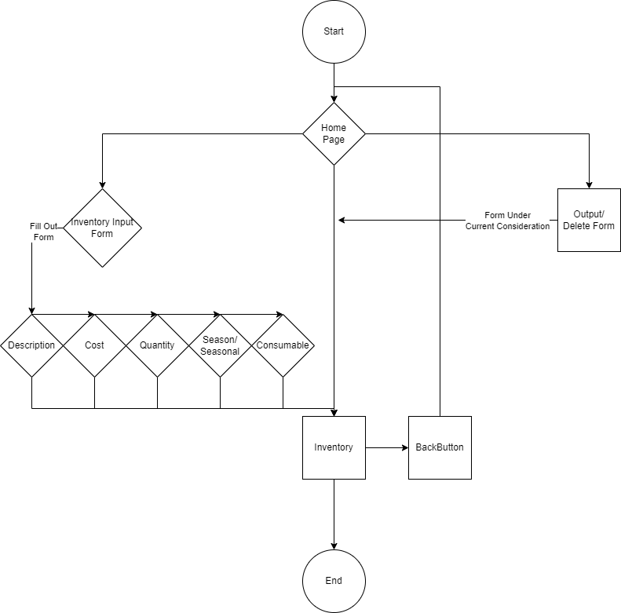

Some important changes here, the output form no longer is going to a separate page, and instead I plan on having it access the inventory directly, while the inventory now has a back button to allow the user to go back to the main page. The overall format was adjusted with more understanding of the flowchart to make it a little neater on the eye as well.